
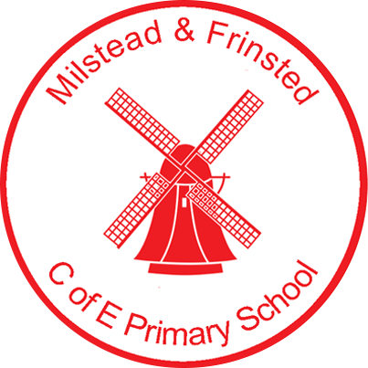
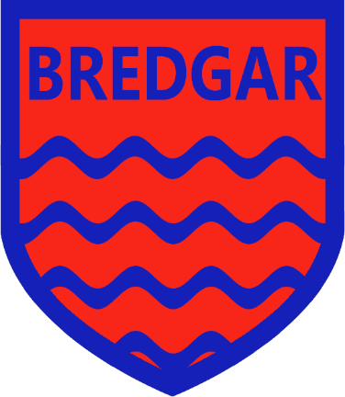

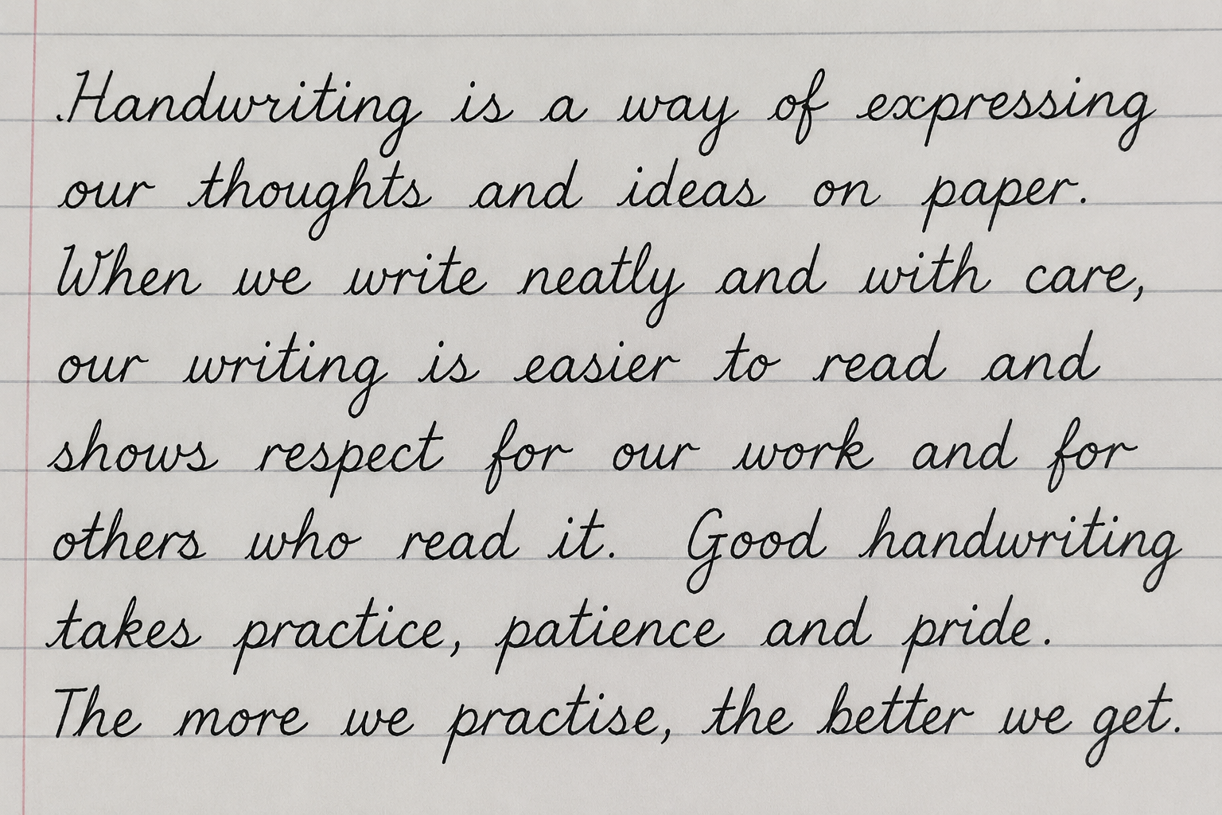

“Learning to speak, read and write well are crucial for children and young people’s success in education, life and work.”
DFE – The Writing Framework 2025
Version: 0.1
Date: 3rd July 2026
English Curriculum

Contents

Why does fluency matter?..........................................................................................................P2
What does the research say? …………………………………………………………………………P3-5
What does this look like in our Schools?....................................................................................P6
A model for English teaching, how is this taught in our Schools?................................................P7
Statutory requirements………………………………………………………………………………….P8-9
Long Term plan, skills and knowledge ………………………………………………………………P10 -18
How do we utilise meaningful assessment and feed this into practice? ………………………… P19 - 21
Adaptive teaching; What do we do to enable all learners to thrive?............................................P22-23
Developing fluent communicators into confident writers:
Why does fluency in writing matter?
Writing fluency matters because it enables pupils to transform ideas into coherent, accurate and purposeful text with increasing ease. When writing becomes more fluent, cognitive resources are released from the mechanical demands of transcription and can be directed towards composition, vocabulary choice, sentence construction and audience awareness. This shift is central to secure writing development and is strongly supported by research.
The Education Endowment Foundation (EEF) identifies transcription, including spelling and handwriting, as a foundational element of writing. Their literacy guidance emphasises that pupils who struggle to form letters, spell automatically or maintain pace are less able to focus on the higher-order aspects of writing. In practical terms, limited fluency can inhibit expression, reduce motivation and constrain the complexity of written outcomes. Conversely, when transcription becomes increasingly automatic, pupils are better positioned to organise ideas and refine meaning.
The EEF writing framework further highlights writing as a complex, multi-component process involving planning, drafting, revising, editing and transcription. Fluency supports each stage of this process. During planning, fluent writers are more able to hold ideas in mind and select an appropriate structure. During drafting, they can sustain sentence flow and maintain coherence. During revising and editing, they are more capable of reviewing their own work critically because the physical act of writing places less burden on working memory. As a result, fluency is not merely a technical skill; it is an enabling condition for effective composition.
In classrooms, fluency in writing has significant implications for equity and attainment. Pupils who write slowly or laboriously may produce shorter responses, demonstrate less developed vocabulary and struggle to show what they know. This can mask understanding and depress achievement across the curriculum, particularly in subjects where extended writing is required. A fluent writer is therefore not simply faster, but more capable of communicating knowledge clearly, precisely and independently.
Developing fluency requires deliberate and sustained practice. The EEF recommends structured opportunities for transcription practice, sentence combining, modelled writing and explicit teaching of writing processes. These approaches help pupils to internalise patterns of language and sentence construction, thereby increasing accuracy and speed over time. Importantly, fluency should be understood as cumulative: the more secure pupils become with spelling, handwriting and sentence control, the more confidently they can write with purpose.
In summary, fluency in writing matters because it underpins expression, supports composition and allows pupils to communicate ideas with clarity and confidence. It is a crucial bridge between fluent communication and successful written performance.
Please see the transcription policy (September 2026) for further details on how this is implemented within our schools curriculum.

Developing fluent communicators into confident writers:
What does the research say?
Introduction
The development of confident writing is not achieved through transcription practice alone. Research consistently indicates that effective writers are fluent communicators who can organise ideas, select language deliberately, and adapt their expression to purpose and audience. In English primary education, particularly in Key Stages 1 and 2, the most effective approaches to improving writing combine oracy, reading fluency, explicit teaching of composition, and sustained opportunities for purposeful practice. The Education Endowment Foundation (EEF) provides a strong evidence base for this view, emphasising that literacy development is most successful when speaking, reading, and writing are taught as interconnected processes rather than isolated skills. Along side this informing our practice are our OCMAT teaching and learning principles – Click Here. This document guides teaching and learning, environments as well as assessment and instruction and as informed out approach.
Oracy as the Foundation for Writing
A substantial body of research highlights the importance of oracy in supporting written composition. Children who can articulate ideas clearly are better able to plan, rehearse, and refine what they write. The EEF has identified oral language approaches as especially valuable in KS1 and KS2, with gains in vocabulary, narrative structure, reasoning, and grammatical control. Spoken language enables pupils to shape meaning before committing words to paper, reducing the cognitive load associated with composing sentences and organising text.
Other research reinforces this principle. When pupils are given structured opportunities to discuss, explain, justify, and retell, they develop the linguistic resources needed for writing. Talk does not simply precede writing; it actively supports the internalisation of language patterns. Dialogic teaching, teacher modelling of subject-specific language, and partner discussion all contribute to improved composition. In particular, children who hear and use sophisticated vocabulary in meaningful contexts are more likely to transfer that language into their written work.
Reading Fluency and Its Relationship to Writing
Reading fluency is another critical contributor to writing development. The EEF recognises reading fluency as more than accurate decoding; it includes pace, expression, phrasing, and automaticity. Fluent reading frees cognitive resources so that pupils can focus on meaning, structure, and authorial choices. This matters because strong writers are typically avid and attentive readers who internalise how sentences, paragraphs, and texts are constructed.
Research suggests that repeated exposure to well-written texts gives pupils models of grammar, vocabulary, and composition. Reading aloud, echo reading, and assisted reading can improve fluency and comprehension, while also enhancing pupils’ sensitivity to rhythm and syntax. When children read widely and fluently, they encounter the conventions of effective writing in authentic contexts. This supports their ability to imitate and adapt these features in their own compositions.
Teaching Composition through Modelling and Supported Practice
The EEF places particular emphasis on explicit teaching of composition. Writing is a complex process, and pupils benefit from clear demonstrations of how to generate ideas, structure content, and revise sentences. Modelling by the teacher is therefore essential. Effective modelling makes the invisible visible: it reveals how experienced writers think, select vocabulary, and improve their drafts. Think-alouds, live writing, and shared composition allow pupils to observe expert decision-making in real time.
Supported practice should follow modelling. Research shows that pupils learn more effectively when guidance is gradually withdrawn. In writing, this may include jointly constructed sentences, guided planning frameworks, oral rehearsal of ideas, and scaffolded independent tasks. Such approaches enable children to practise the craft of writing while still receiving enough support to succeed. The aim is not dependence on templates, but the progressive development of independence and control.
Writing with Purpose and Audience
Another important strand of research concerns purpose and audience. Children write more effectively when tasks are authentic and meaningful. When the intended reader is clear, pupils are more likely to make considered choices about vocabulary, tone, sentence structure, and text organisation. The EEF and other literacy research both indicate that purposeful writing improves engagement and supports stronger outcomes because pupils understand why they are writing and for whom.
Writing for a real or plausible audience gives composition a communicative function. Letters, reports, instructions, and persuasive texts all require different linguistic decisions. By exploring audience expectations, pupils learn that writing is not merely a school exercise but a social act. This awareness strengthens both motivation and technical accuracy.
The Importance of Repeated Application
Research is clear that writing improves through frequent, meaningful practice. Children need many opportunities to apply newly taught skills across the curriculum. Short, focused writing tasks are useful, but longer extended pieces are also necessary for pupils to consolidate learning and develop stamina. Repetition should not mean redundancy; rather, skills should be revisited in varied contexts so that pupils transfer them independently.
The most effective classrooms provide regular chances to write for different purposes, in different subjects, and for different audiences. This breadth encourages flexibility and secures learning. It also allows teachers to identify misconceptions and provide timely feedback. Over time, repeated application supports fluency, confidence, and precision.
Conclusion
The research is consistent: confident writers are developed through a rich blend of spoken language, fluent reading, explicit composition teaching, and sustained practice. The EEF’s guidance for KS1 and KS2 aligns closely with wider evidence that children write best when they can rehearse ideas orally, read fluent and well-crafted texts, observe expert modelling, and apply their learning in purposeful contexts. Writing is therefore best understood not as a stand-alone skill, but as the culmination of a carefully sequenced literacy curriculum in which talk, reading, and writing reinforce one another.
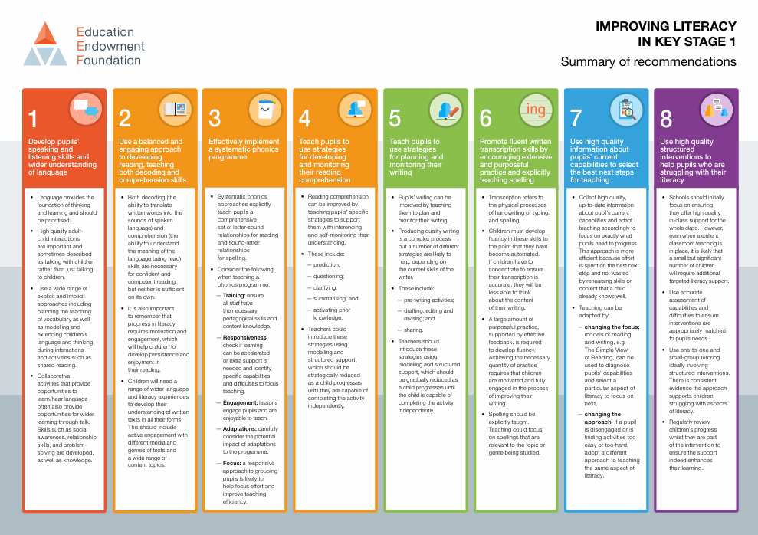

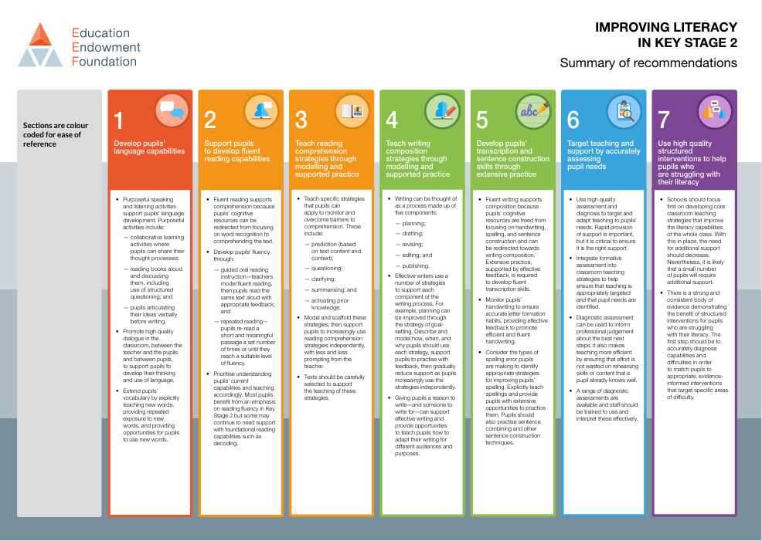
https://d2tic4wvo1iusb.cloudfront.net/production/eef-guidance-reports/literacy-ks2/EEF-Improving-literacy-in-key-stage-2-report-Second-edition.pdf
https://d2tic4wvo1iusb.cloudfront.net/production/eef-guidance-reports/literacy-ks-1/Literacy_KS1_Guidance_Report_2020.pdf
EEF EYFS/KS1 literacy study | Develop pupils’  speaking and  listening skills and  wider understanding  of language | Use a balanced and  engaging approach  to developing  reading, teaching  both decoding and  comprehension skills.  Effectively implement  a systematic phonics  programme | Teach pupils to  use strategies  for developing  and monitoring  their reading  comprehension | Teach pupils to  use strategies  for planning and  monitoring their  writing | Promote fluent written  transcription skills by  encouraging extensive  and purposeful  practice and explicitly  teaching spelling. | Use high quality  information about  pupils’ current  capabilities to select  the best next steps  for teaching | Use high quality  structured  interventions to  help pupils who are  struggling with their  literacy
EEF KS2 Literacy study | Develop pupils’  language capabilities | Support pupils  to develop fluent  reading capabilities | Teach reading  comprehension  strategies through  modelling and  supported practice | Teach writing  composition  strategies through  modelling and  supported practice | Develop pupils’  transcription and  sentence construction  skills through  extensive practice | Target teaching and  support by accurately  assessing  pupil needs | Use high quality  structured  interventions to help  pupils who  are struggling with  their literacy
What this looks like in our schools | - High quality continuous provision.  - High quality opportunities through oracy within comprehension.  - explicitly teaching new words and vocabulary within the curriculum. | Little Wandle phonics from EYFS onwards into fluency from year 2 until pupils are confident readers moving onto AR. | - Little Wandle from EYFS, through to fluency and on to VIPERS once fluency has been achieved.  - AR  - Through the comprehension strand within the English curriculum. | -Through our tools for writing phase of the English curriculum, embedded within a high-quality text.  -Through our writing phase of the curriculum pupils will have the opportunity to plan, engage with modelled texts and scaffolded writing opportunities. | -Through our Schools transition policy.  - Through explicit daily handwriting.  - Through explicit daily phonics/ spelling.  -modelled metacognitive strategies throughout teaching. | - Use snapshots for termly summative assessments  -Merit GPS assessments  - use verbal feedback and hot marking within lessons for instant feedback  - feed targets into planning.  -Teaching and learning policy – Revisit and practice sections within lessons enable identification of misconceptions. | - OCMAT inclusion strategy.  -adaptive teaching crib sheets.  - support slips.  - schools individual high quality interventions e.g. language link, precision teaching, fine motor skills.
Developing fluent communicators into confident writers: What does this look like in our Schools?
Developing fluent communicators into confident writers:
A model for English teaching, how is this taught in our Schools?
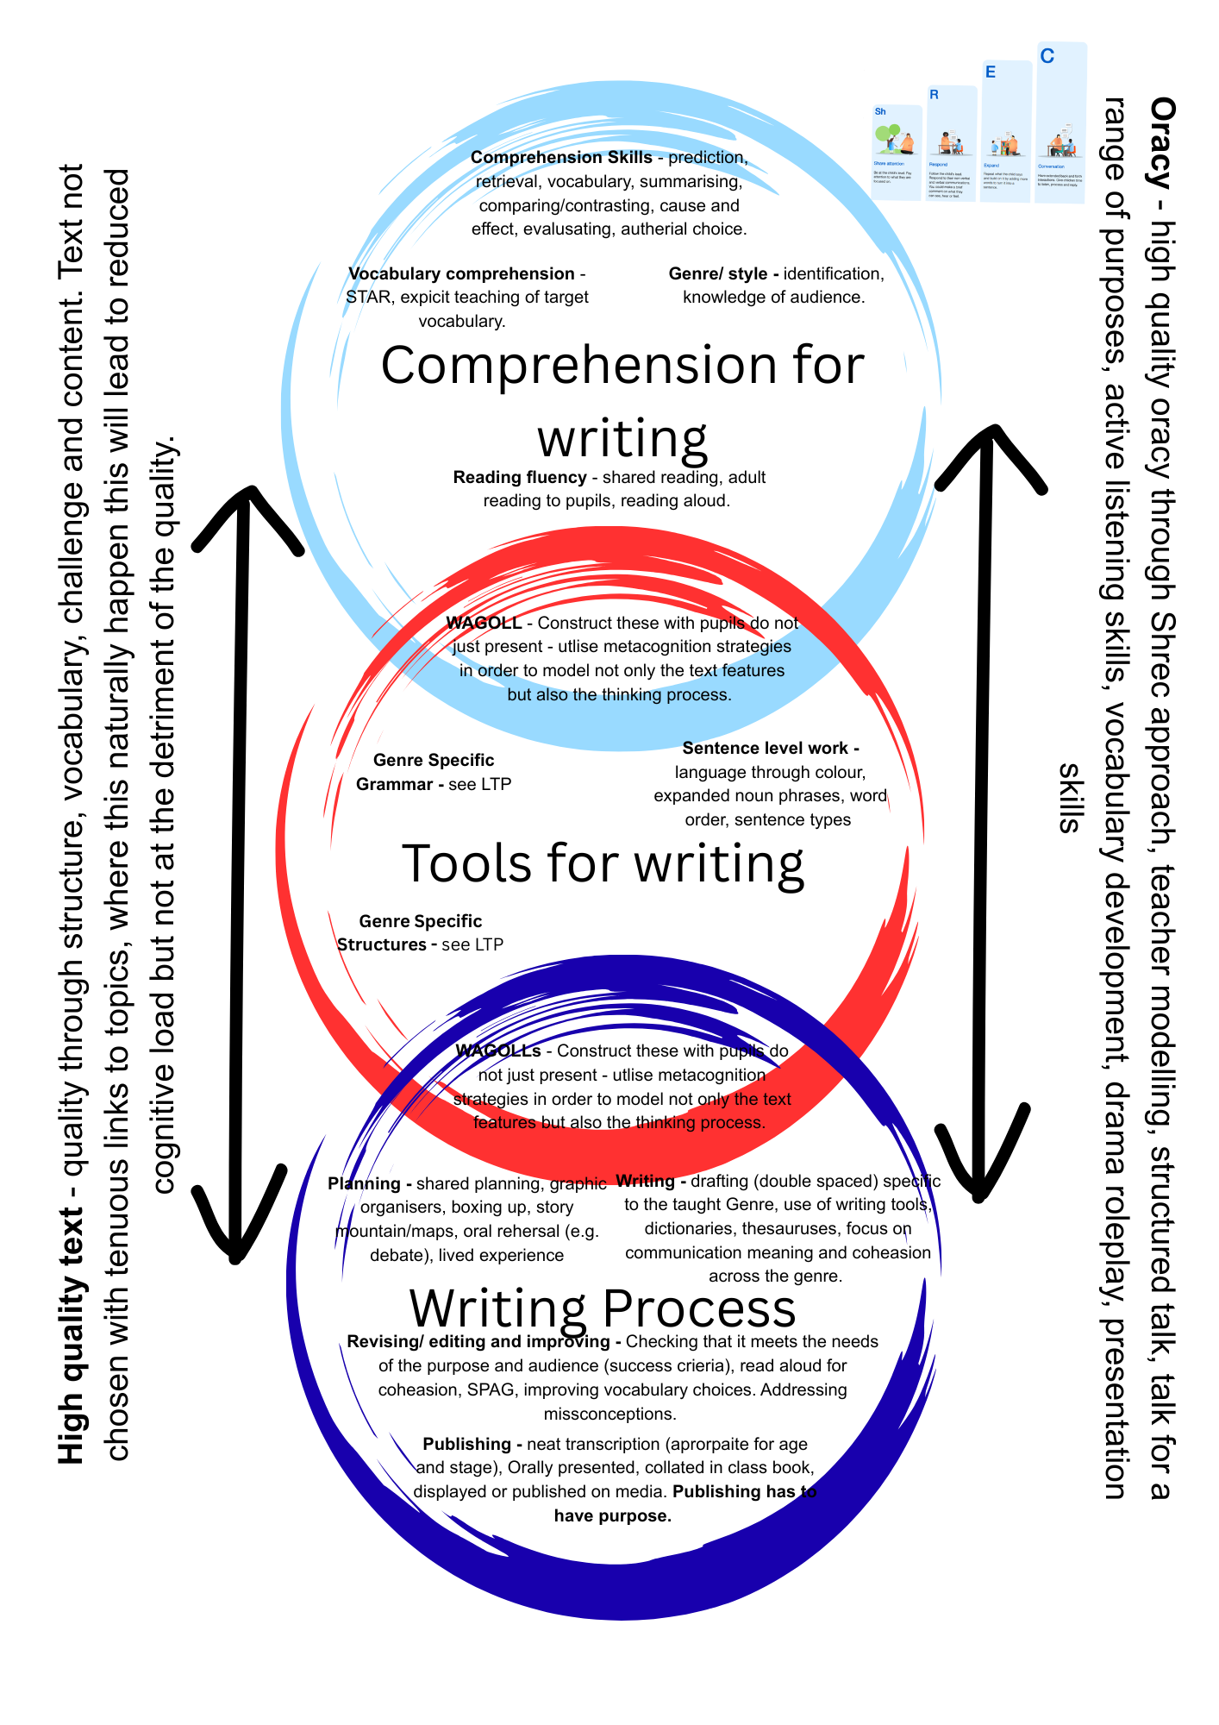

Developing fluent communicators into confident writers:
Statutory Requirements: What does the EYFS framework (July 2025) National Curriculum in England (July 2024) and the Writing Framework (July 2025) set out for writing across all year groups?
Within the Early Years Foundation Stage, writing develops through meaningful opportunities to communicate ideas. Children begin by strengthening their speaking and listening, as oral language underpins successful writing. They are encouraged to retell stories, use new vocabulary, and express thoughts with increasing clarity. Early mark-making leads to controlled pencil grip, letter recognition, and the formation of simple words and sentences. Writing is closely linked to physical, social, and cognitive development, with practitioners modelling language and providing purposeful activities. Assessment focuses on children’s confidence, motivation, and emerging ability to communicate for different purposes across the EYFS.
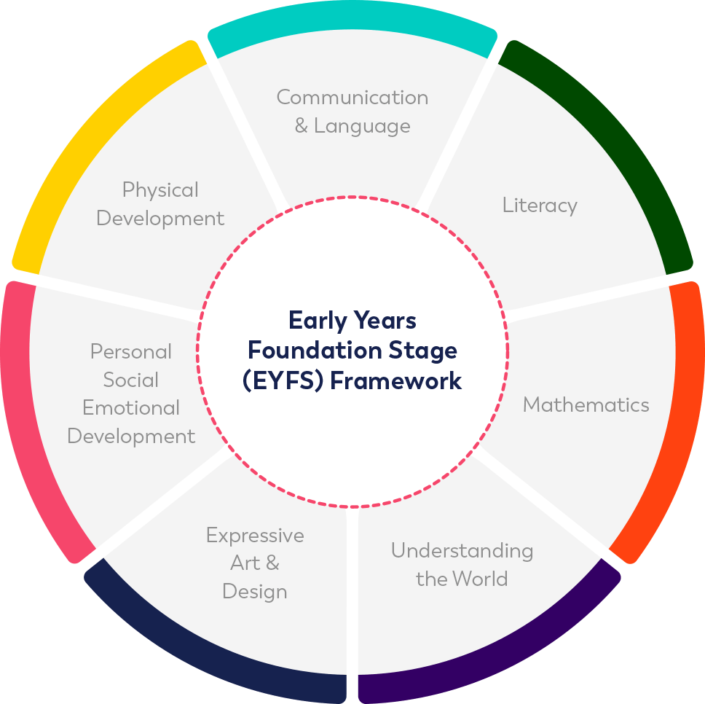
Click the icons above to read policy documents
The primary writing curriculum in England sets out a progressive entitlement for pupils from Key Stage 1 through to Key Stage 2, with an emphasis on developing confidence, accuracy and control in composition, transcription and spoken language. By July 2024, the central principles remain focused on enabling children to communicate clearly, to write for a range of purposes and audiences, and to speak fluently and appropriately in formal and informal contexts.
In the early primary years, pupils are expected to build secure foundations in oral language, sentence construction and basic transcription. Speaking and listening are integral to this stage. Children are encouraged to ask and answer questions, retell events, participate in discussions and speak audibly with increasing confidence. These experiences support the development of vocabulary, grammar and the organisation of ideas before writing is attempted independently. In writing, pupils are taught to compose simple sentences, sequence ideas logically and use phonics-based spelling strategies. Handwriting, punctuation and capitalisation are introduced systematically so that accuracy becomes habitual.
Across Key Stage 1, pupils extend these skills by writing increasingly coherent texts, including narratives, recounts and simple non-fiction. They learn to punctuate sentences with greater precision, to use conjunctions to join ideas, and to begin to vary vocabulary for effect. Spoken language continues to be essential, with pupils expected to explain, justify and rehearse ideas orally before recording them in written form. The curriculum encourages children to read aloud, perform poems and talk about their writing in order to strengthen fluency and confidence.
In Key Stage 2, the curriculum becomes more demanding, with a stronger emphasis on audience, purpose and formal structure. Pupils are taught to plan, draft, edit and improve their writing with growing independence. They are expected to select vocabulary carefully, shape paragraphs purposefully and use grammatical features such as fronted adverbials, clauses and varied sentence structures. Spelling, punctuation and handwriting remain important, but they are now developed in relation to more ambitious composition. Speaking and listening continue to play a significant role, particularly in discussion, presentation and collaborative learning, where pupils refine their ability to express ideas clearly and adapt language for different contexts.
By the end of the primary phase, pupils should be able to write fluently and accurately for a variety of purposes, demonstrating control over grammar, punctuation and spelling. They should also speak with clarity, listen attentively and respond thoughtfully, showing the oral language skills that underpin successful writing and wider academic achievement.

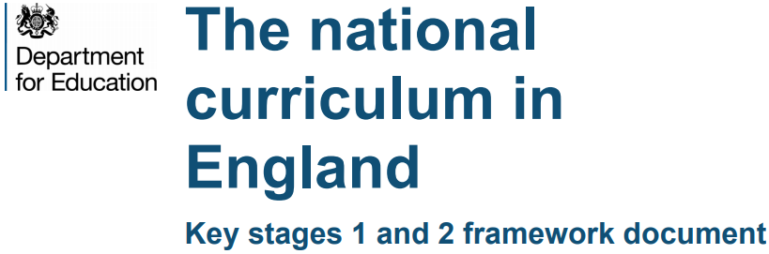
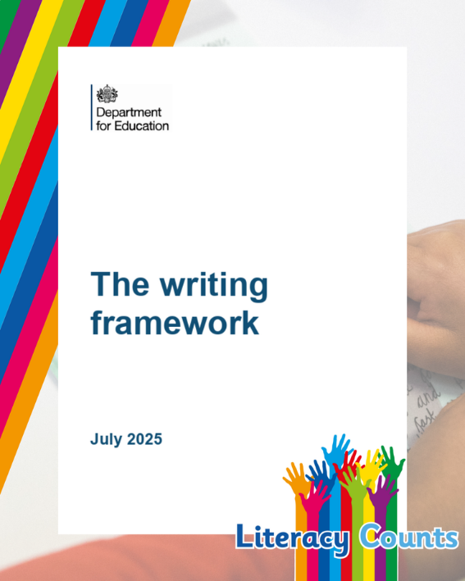

Click above to read policy documents
Developing fluent communicators into confident writers:
Our long-term plan and progression of skills and knowledge
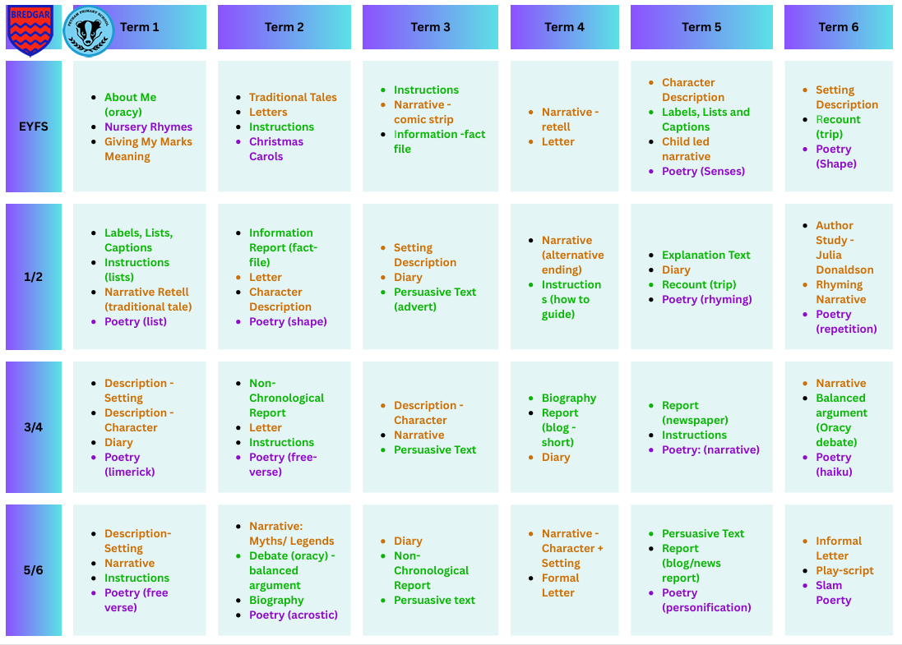
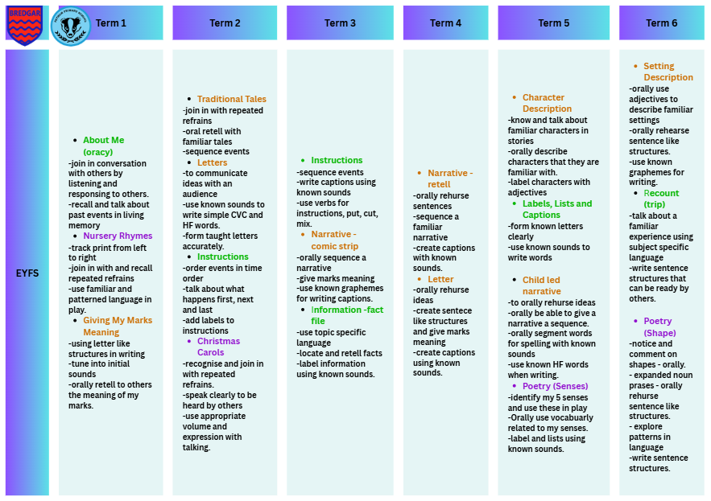
SPAG Progression
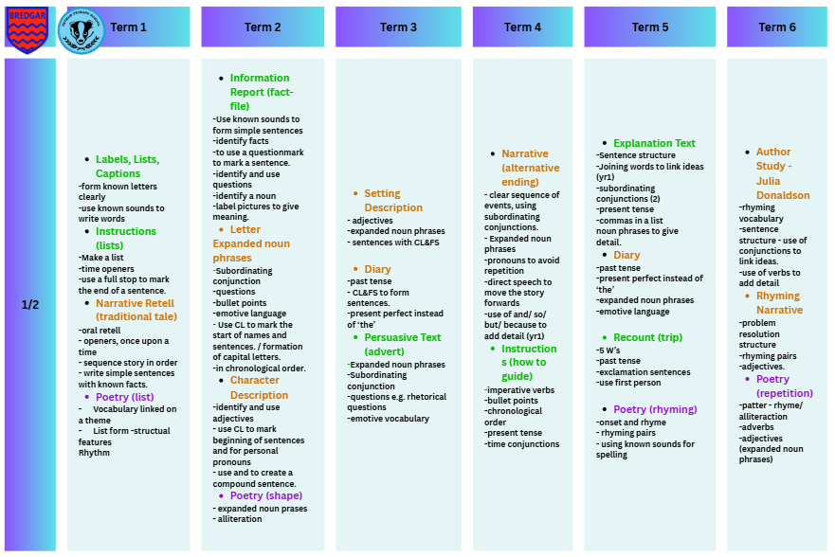
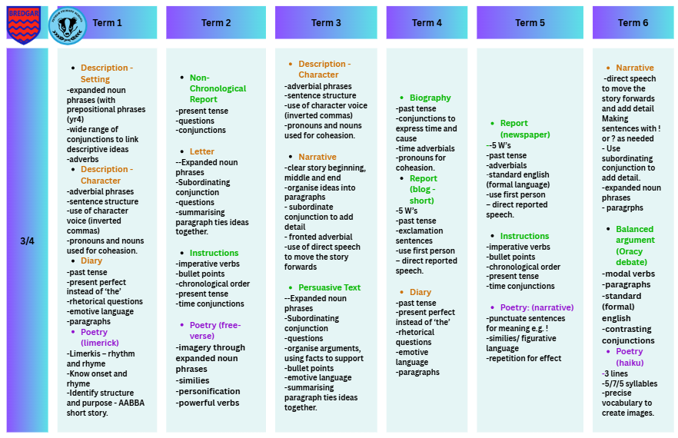
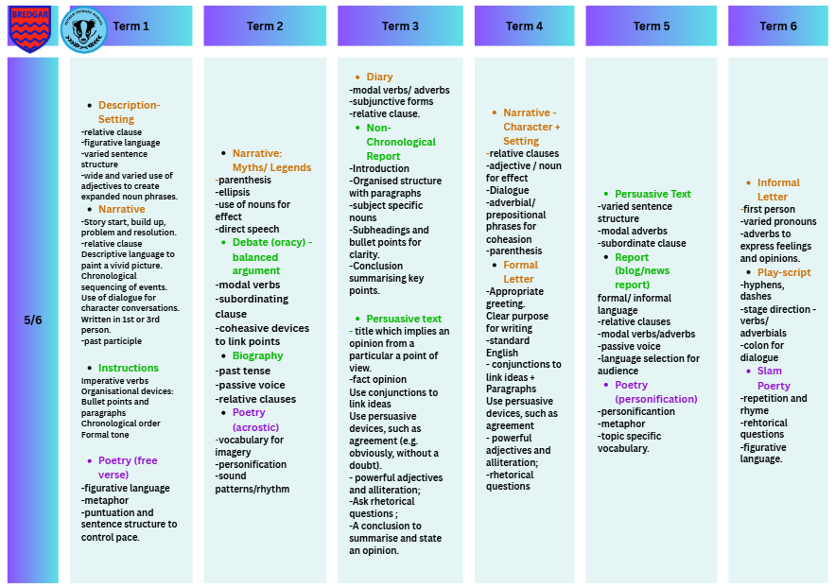
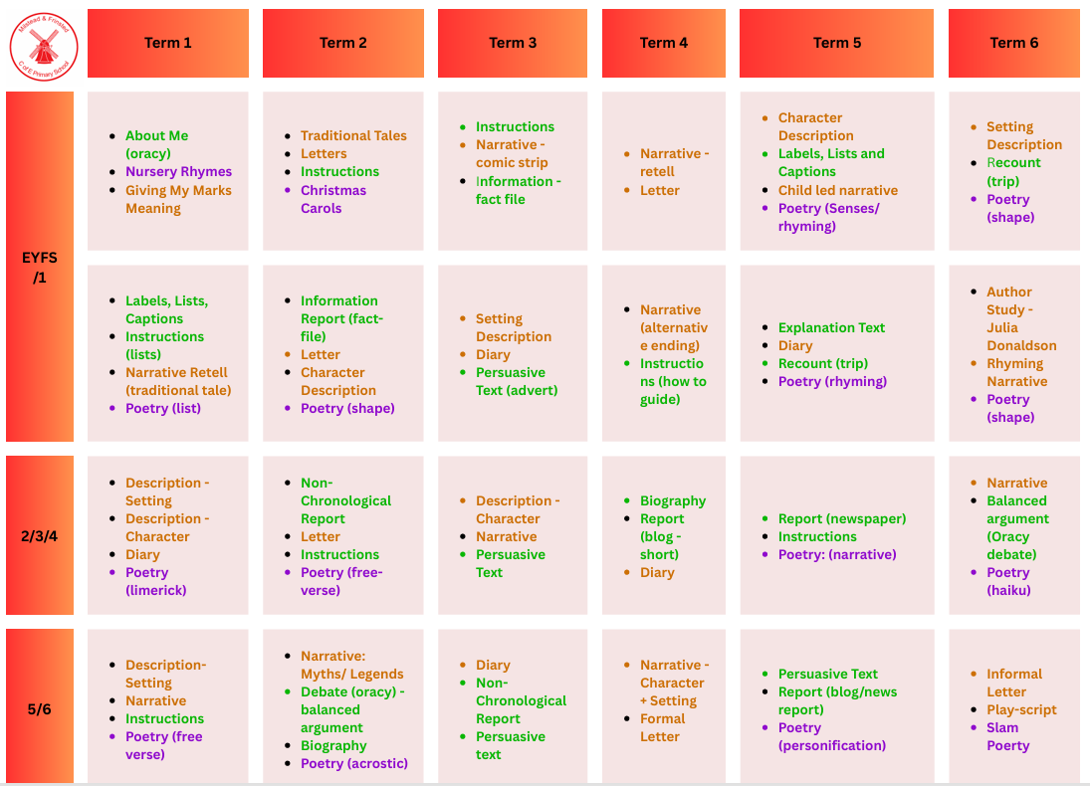
Genre overview – Milstead & Frinsted
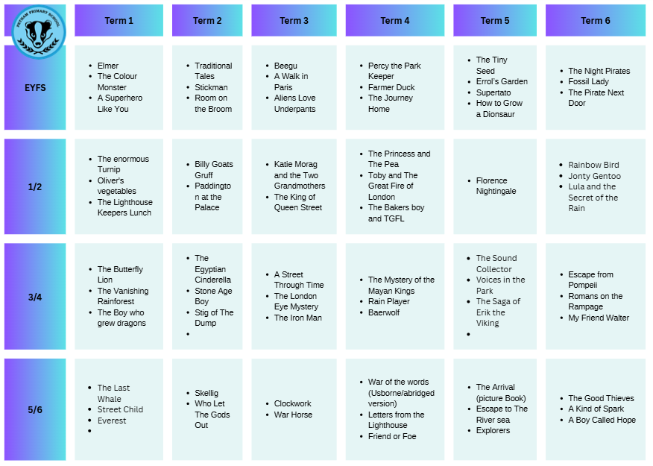
Text Mapping
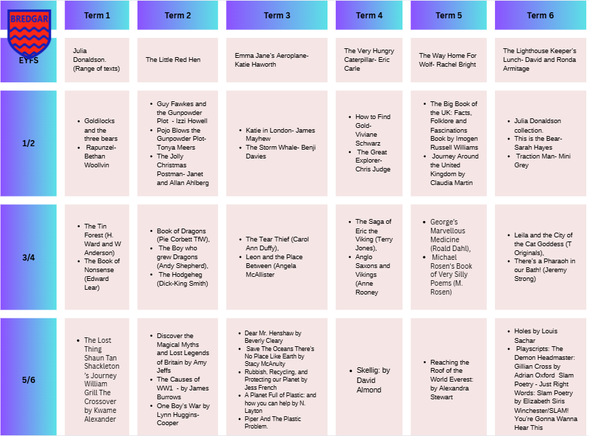

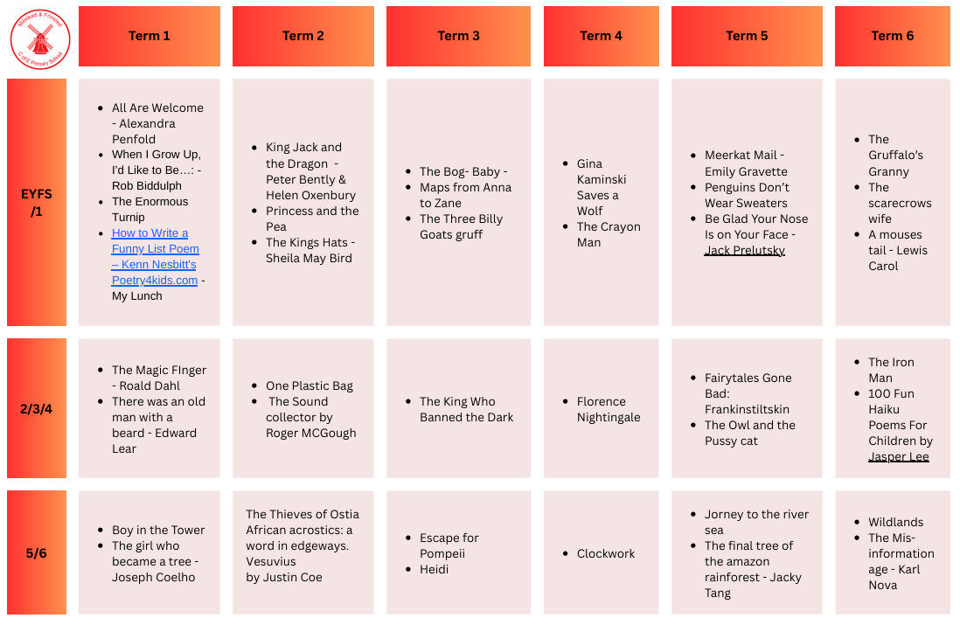

Developing fluent communicators into confident writers:
How do we utilise meaningful assessment and feed this into practice?

Assessment is integral to high-quality writing provision because it allows teachers to build a secure understanding of each child’s attainment, progress and next steps. We assess through a rage of tools to gain a balance understanding of children’s skills and knowledge of the English curriculum. This ensures that judgments are informed by a wide range of evidence, rather than by a single piece of work or an isolated outcome. Assessment information is used to identify what children can do independently, where support is needed, and what should be taught next.

Snapshots - Click Here
Snapshots cover the knowledge and skills, as indicated by the national curriculum and through the ELG and end of KS2 standards. These will be completed termly for every child and make up their focus/ target. You may wish to complete these digitally and then print and place them in books. These will be printed on blue or green paper to be quickly identified within the book. Target statements that have been achieved and are evident within the book can be highlighted green and target statements highlighted pink. Not all statements have to be highlighted as these skills may not have been covered at this point. Snapshots are statements, that at the end of the year, is what a writer of that standard looks like, where a child in on track to achieve AE or GD then award them those grades e.g. for T3 in year 3 a pupil may have mostly achieved AE and some GD elements award them GD in T3 as this is reflective of the skills and pathway they are on.
If a child is working towards the age expected snapshot, then they should be using the snapshot for the year they are in. If a child is below, then to assess how many years/ months below they are use the snapshot that is best fit for their skill level. This may then mean a child in year 3 is using the year 1 or year 2 snapshot. Accuracy in assessment is vital so targets can be meaningful and have the biggest impact. Pupils when assessed at the right level, are more likely to make rapid progress as gaps are being addressed.
Greater depth assessment can be challenging; snapshots quantify greater depth and what this looks like. If children are showing greater depth, then award them this assessment grade with confidence using the assessment guidance within the snapshots. Teachers should use the statements within the snapshot to support secure assessment decisions and to ensure that evidence is matched to the correct standard. Where children demonstrate consistent independence, breadth and depth of understanding, this should be recognised in the assessment outcome.

MERiT GPS
In terms 2, 4 and 6 pupils will undertake standardised assessments for reading, maths and GPS within assessment weeks (see assessment calendar). These assessments enable you, as teachers, to generate an age-standardised score, scaled score, population comparison and question by question analysis. This will then enable you to target themes in pupil understanding and possible misconceptions. It will also allow you to design specific interventions for those children who need a more bespoke package to keep up and remain on track. Not only this but it enable you to identify pupils who are nearly at greater depth and the details needed in order to get them there.
The outcomes from these assessments should be considered alongside day to day writing evidence, teacher observation and snapshot judgements. The age-standardised score and scaled score provide a useful comparison with national expectations, while the question by question analysis highlights precise areas of strength and need. This information should inform planning, reteaching and support within lessons, alongside intervention where required.

Pupil Progress Meetings
From our assessment tools we can then triangulate pupil progress and plan specific and meaningful intervention so that they can reach their full potential. These discussions will pull together all assessment information to give a full and balanced picture for each child and also allow us to pull out common themes from each cohort. Pupil progress meetings should focus on the evidence held across the snapshots, standardised assessments, written work and teacher knowledge of the child. This enables leaders and teachers to identify patterns, review impact and agree next steps.
During these meetings, teachers should be ready to discuss children who are on track, those who are below age-related expectations, and those demonstrating greater depth. Particular attention should be given to pupils whose progress is not yet secure, so that support can be adjusted promptly. Common themes from across the cohort should be recorded and used to shape future teaching, curriculum adjustments and intervention planning. This ensures that assessment is not a standalone process, but part of an ongoing cycle of identification, response and review.

Assessment Principles

Assessment in writing should be accurate, purposeful and manageable. It should reflect the full range of evidence available and support informed professional judgement. Teachers should use assessment information to:
- identify gaps in knowledge and skills
- match work to the correct level of challenge
- plan next steps that are precise and relevant
- monitor the impact of teaching and intervention
- recognise when a pupil is ready to move on
- identify pupils who require greater depth challenge
- ensure consistency across classes and year groups

Assessment is most effective when it is used regularly and consistently. The purpose of assessment is not simply to record outcomes, but to improve teaching and learning. Teachers should refer to the snapshot guidance, standardised assessment information and classroom evidence to ensure that decisions are robust and well founded. This allows the school to maintain a clear picture of attainment across the curriculum and to respond to the needs of individuals and groups with clarity.
All assessment information should be used professionally and discreetly, with a clear focus on securing the best possible outcomes for pupils.
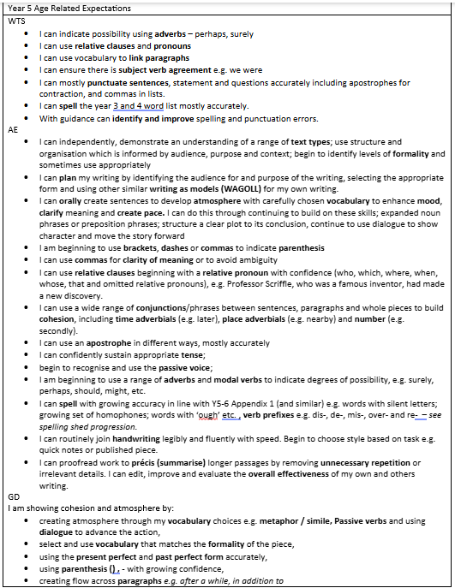

Developing fluent communicators into confident writers:
Adaptive teaching; What do we do to enable all learners to thrive?
At OCMAT, inclusion is not an additional strategy, nor a discrete area of school improvement. It is the standard by which we judge the quality of education across our schools. We do not see inclusion as something that sits alongside teaching and learning. Instead, it is reflected in the everyday decisions teachers and leaders make: how the curriculum is designed, how lessons are delivered, how pupils are supported to participate, and how barriers to learning are identified and addressed. Our Teaching and Learning Principles already set out our expectations for great teaching across the Trust. These principles are deliberately inclusive by design. They place pupils facing the greatest barriers at the forefront, not as an afterthought, but as the starting point. When these principles are applied consistently and effectively, they reduce the need for additional, reactive support and create classrooms in which all pupils can succeed. In this sense, inclusion is not about doing more for some pupils. It is about doing the right things for every pupil, with precision, consistency, and care. We recognise that pupils with SEND, and those facing other forms of vulnerability, often experience school differently. They are more likely to encounter barriers related to language, cognition, emotional regulation, attendance, and access to the curriculum. Our responsibility is not to work around these barriers through layers of provision, but to design teaching, environments, and systems that minimise them from the outset. This requires a shift from seeing inclusion as the responsibility of the SENCo or a specialist team, to understanding it as a collective responsibility across all roles. Class teachers remain central to this work. Subject leaders play a critical role in ensuring that curriculum design supports access for all learners. School leaders are responsible for creating the conditions in which inclusive practice can thrive, and for addressing inconsistency where it exists. At Trust level, our role is to bring coherence, alignment, and clarity.
We do this by:
• establishing shared expectations for high-quality teaching and inclusive environments
• supporting schools to identify need accurately and early
• developing staff expertise through a structured and evidence-informed professional development offer
• enabling collaboration across schools so that strong practice is shared and refined
• providing appropriate pathways and specialist support where needed, without losing focus on the core offer
We are deliberate in avoiding an over-reliance on intervention or the ‘labelling’ of need. Identification of SEND is important, but it is not the starting point for support. Strong teaching, effective assessment, and a clear understanding of pupils’ needs must come first. Where additional support is required, it should be purposeful, time-limited, and designed to build independence rather than dependency. Inclusion at OCMAT also extends beyond the classroom. Attendance, behaviour, safeguarding, and wellbeing are integral to a pupil’s ability to access education. Our approach brings these elements together, recognising that barriers rarely sit neatly within one category. This allows us to respond to pupils as individuals, rather than as labels or groups. Ultimately, our ambition is to create equitable classrooms across all our schools. Classrooms where expectations are high, teaching is responsive, and every pupil experiences a sense of belonging and success. This is not achieved through isolated strategies, but through consistent, aligned practice over time.
Inclusion strategy – click here

Adaptive crib sheets
The starting point for these crib sheets has been Nasen. Their research-informed guidance on high quality and inclusive teaching, together with their work on ordinarily available provision, has provided a clear foundation for the approach. This ensures that the crib sheets are grounded in evidence and aligned with current thinking about effective practice for all learners.
The purpose of these documents is to enable our schools to provide a robust and inclusive offer. They support staff in planning and delivering adaptive teaching that removes unnecessary barriers, strengthens access to the curriculum, and responds to need in a practical and proportionate way. In doing so, they promote consistency while recognising that effective adaptation depends on professional judgement and knowledge of the class, the subject, and the individual pupil.
These crib sheets are intended to be used as a reference point for everyday teaching, professional discussion, and collaborative planning. They help to make inclusive practice more explicit and to ensure that the support offered across OCMAT is coherent, purposeful, and rooted in research.
Click logo for crib sheets:

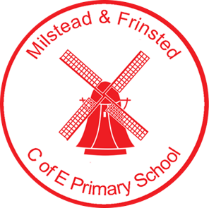

Support Slips
Support slips are in place to identify the most effective strategies that have worked and enabled learners to be successful. They provide a clear record of where support is given, allowing staff to track patterns and make informed decisions about next steps.

These slips also ensure that support is communicated effectively across professionals. When adults record what has been used, when it was used, and the impact it had, this helps to maintain consistency and shared understanding. As a result, provision can be adjusted more accurately to meet individual needs.
Support slips also have an important role in developing pupil independence. They enable pupils to be reflective and to build a bank of metacognitive strategies that help them identify what works best for them. Over time, this may support pupils to select and apply strategies more independently.
The long-term aim is for pupils to reach a stage where they use these strategies without needing prompting or scaffolding by an adult first. In this way, support slips contribute both to effective communication among professionals and to the gradual development of self-regulated learning.
Click here for Support Slips

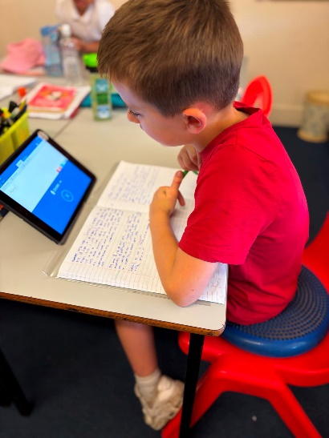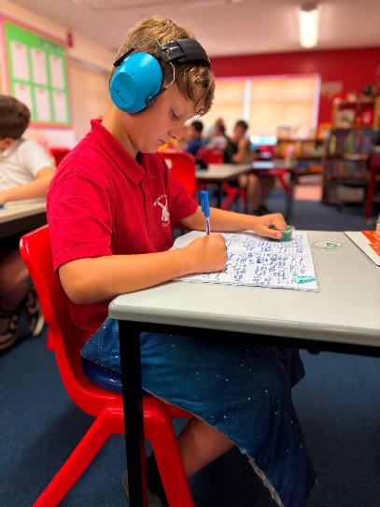
Petham Primary School
01227 700260
www.petham.kent.sch.uk
Milsted and Frinstead CofE Primary School
01795 830241
www.milstead.kent.sch.uk
Bredgar CofE Primary School
01622 884359
www.bredgar.kent.sch.uk
Our Community Multi-Academy Trust
www.ocmat.org.uk

